**T.C.  
DOKUZ EYLUL UNIVERSITY  
FACULTY OF ENGINEERING**

**CME 3204 Data Communications and Computer Networks**

**Metropolitan Area Network Simulation**

**by**  
  
 **2020510083 Abdulkadir Öksüz**

**May 2024**



# **CHAPTER ONE**

# **Introduction**

## **1.1. Project Definition and Problem Formulation**

Computer network planning and design involves creating a blueprint for a network that meets an organization's needs. It requires analyzing needs, designing the network topology and architecture, and determining traffic characteristics. A well-designed network should support a maximum number of users, handle high traffic with minimal delay, and have hardware to support expansion while balancing costs against requirements.

This project involves designing a Metropolitan Area Network (MAN) connecting two branches of an office using Cisco Packet Tracer. The MAN will connect the branches through routers over an Internet Service Provider (ISP), considering connection technologies between the ISP and branches.

The first branch has three facilities with varying users and needs. The first facility has 3 PC users, 3 laptop users, and 3 smartphone users who can browse, email, and transfer files. The second facility has 6 PC users for web/FTP and 2 PCs for VoIP conferences. The third facility has a server farm with 10 web servers, 4 FTP servers, 1 DHCP server, 1 email server, and 1 DNS server.

The second branch also has three facilities with different users and needs. The first facility has 5 PC users, 5 laptop users, and 5 tablet users using wireless to browse, email. The second facility has 5 PC users and 2 smartphone users who can browse, edit files, and transfer files. The third facility has 5 PCs and 2 mobile devices for browsing and emailing.

Designing the MAN network requires considering topology, architecture, and traffic characteristics. The topology defines the physical layout while the architecture defines the logical structure. Networking devices like routers, switches, and hubs must be chosen appropriately. Traffic characterization helps determine bandwidth needs for each facility and device. Cost and requirements must also be balanced.

In conclusion, MAN design is complex, requiring careful planning around factors like topology, architecture, traffic, costs, and requirements to support maximum users and traffic with minimum delay.

## **1.2. The purpose and motivation of the project**

The purpose of this project is to design and build a Metropolitan Area Network (MAN) that meets specified requirements and specifications. The MAN will connect two branches located in a city via routers over an Internet Service Provider (ISP). The first branch has three facilities with different needs, as does the second branch. The goal is to create an efficient network architecture supporting a maximum number of users, handling traffic with minimal delay, and providing hardware support for expansion.

The motivation is to develop a reliable, efficient network meeting organizational communication and data transfer needs. Networks are critical for business operations and effective communication. A well-designed network improves productivity, reduces downtime, and minimizes data loss risk. Moreover, network design is iterative, allowing adaptation to technological and business changes.

The business goal is a cost-effective, efficient architecture meeting communication and data transfer demands. A reliable, efficient MAN ensures employee access to resources and applications while handling traffic loads with minimal delay, improving productivity, reducing downtime, and minimizing data loss risk.

The main benefit is a reliable, efficient network satisfying organizational needs. It will handle traffic loads with minimal delay in a cost-effective, sustainable way. The MAN improves productivity, reduces downtime, and minimizes data loss risk.

Potential risks include the network not meeting requirements/specifications, leading to delays and excess costs. Security breaches also risk data loss or unauthorized access. Additional resources and expertise may increase costs and complexity. However, benefits outweigh risks, and a well-designed, implemented architecture provides significant advantages.

## **1.3. Term Definitions**

**Network:** A group of interconnected devices like computers, printers, and servers that can communicate and share resources with each other.

**Metropolitan Area Network (MAN):** A type of network that connects devices over an area larger than a LAN but smaller than a WAN, typically spanning a city or metropolitan region.

Router - A networking device that connects multiple networks and directs traffic between them.

**Internet Service Provider (ISP):** A company that provides internet access to their customers.

**Workstation:** A computer optimized for performance-intensive tasks such as video editing or computer-aided design.

**Wireless user:** Someone who connects to the network remotely using wireless technologies.

**Smartphone:** A mobile phone with advanced computing abilities and internet connectivity.

**Web server:** A computer that stores and delivers web pages over the internet.

**File Transfer Protocol (FTP) server:** A computer that stores and transfers files using the FTP protocol.

**Dynamic Host Configuration Protocol (DHCP) server:** A device that automatically assigns IP addresses to networked devices.

**Mail server:** A computer that handles email communication, storing and forwarding messages.

**Domain Name System (DNS) server:** A computer that translates domain names into IP addresses.

**Wireless connection:** A network connection that uses wireless technologies to transmit data.

**Voice over Internet Protocol (VoIP) conference:** An audio conference that transmits calls over the internet.

**Packet:** A unit of data containing the message and routing information used to transmit it on a network.

**Channel:** The pathway through which data is transmitted on a network.

**Protocol:** The set of rules that govern how data is transmitted on a network.

**System:** A collection of hardware, software, and network components that work together for a shared purpose.

**Network architecture:** The design of a network including its devices, connections, and protocols.

## **1.4. Related Work**

Several publications have contributed to advancing network modeling/simulation and design in various domains. For example:

* A book that provides a comprehensive overview of core concepts, methods, and tools for network simulation. It covers topics like discrete event simulation, mobility models, channel models, link layer models, network layer models, transport layer models, application layer models, simulation frameworks, evaluation methodologies, and visualization tools.
* A book offering a practical guide to using modeling and simulation to solve real-world problems in computer and telecommunication networks. It presents code examples illustrating commonly encountered simulation tasks like generating synthetic traffic, simulating wireless networks, simulating routing protocols, simulating congestion control algorithms, simulating quality of service mechanisms, and simulating security attacks.
* A project aimed at integrating machine learning techniques in network modeling and simulations to evaluate ML-based solutions and algorithms used to configure and optimize networks. It also explores using simulated data to train and evaluate ML models before applying them to real networks.

These works demonstrate the importance and challenges of network modeling/simulation and design for complex large-scale systems. They also show how different fields and technologies can be combined to enhance the accuracy, efficiency, and usability of network modeling/simulation and design tools.

# **CHAPTER TWO**

# **Method and Simulation**

## **2.1. Simulation and Modeling Concepts**

The network design process determined both logical and physical requirements. We used a bottom-up approach during construction, starting with small units and progressively expanding to larger ones. However, we ensured applications/services were included in planning to avoid leaving them as an afterthought. While this is a quick fix approach, we conducted thorough initial analysis and simulation to ensure network effectiveness.

We simulated the branch offices' infrastructure including different user (workstation, wireless, tablet, smartphone) and device (switches, routers, wireless routers, cables) types. We used a DHCP server to assign IP addresses to each facility's users and analyzed device connections between workstations and devices. We also verified the physical connection layout and network tools in facilities. Devices were configured according to specifications.

During simulation, copper straight cables automatically connected workstations and devices. Facilities within branches connected to main switches via fast Ethernet ports. A router connected two adhering-to-same-rules networks. Branch routers connected via serial Ethernet ports. The router manages packages, ensuring delivery to appropriate networks via static routing when a workstation sends a message/email to another on a different network.

The first branch office's third facility established server farms enabling mail/web access, file exchange and VoIP services. Web, DNS, mail, FTP and DHCP servers configured in the server room connected to the server farm main switch, then to the server router. This router connected to the three facilities' main router in the second branch via serial connection, creating a Metropolitan Area Network. After connecting branches, we conducted control trials between workstations through simulations to ensure proper network functioning. We briefly described steps taken. Workstations and devices correctly performed tasks with network cables and devices, providing communication between branches in the city.

## **2.2. Simulation Environment/Tool**

We simulated our design using the Cisco Packet Tracer tool. This simulator is intended to model a variety of network devices like routers, switches, wireless access points, servers and endpoints. Users can drag and drop device representations onto a virtual workspace to construct network topologies closely resembling real ones. Configured and interconnected virtual devices allow creation of complex simulated network designs.

In addition to modeling network structures, Packet Tracer provides simulation features for testing different scenarios. For example, it can mimic network traffic behavior, letting users observe traffic flow through a network and how devices handle it. This makes it suitable for validating configurations and experimenting with new designs by troubleshooting them.

Packet Tracer also incorporates common protocols like TCP/IP, DHCP, DNS and OSPF for simulating their real-world functionality. This allows gaining hands-on protocol experience and understanding how they operate in a simulated environment.

## **2.3. Network Design Requirements**

Our network design meets the specified requirements. The architecture uses a client/server model with various protocols like HTTP, HTTPS, DHCP, DNS, FTP, POP3, TCP, SSH and SMTP for device communication. Network components include five switches, four access points, three routers and ten servers supporting different user types (workstation, wireless, smartphone, tablet, IP phone). The hybrid topology combines star and bus layouts for MAN LANs. Wireless devices connect to WRT300N access points, workstations/servers to 2960-24TT switches, and switches/routers interconnect. For the router connecting F1 and F2 in Branch 1 supporting VOIP, we chose model 2811 unlike other Router-PT routers. This established a reliable, secure Metropolitan Area Network.

## **2.4. Requirement Analysis**

All necessary requirements analysis for the project were conducted according to the information provided. The analysis is as follows:

The metropolitan area network design includes two distinct branches of an office located in a city. The branches are connected by at least two routers each over an internet service provider, considering connection technologies between the ISP and branches.

The first branch's network has three distinct facilities with varying units and requirements. The first facility has 3 PC users, 3 laptop users, and 3 smartphone users able to browse the web, email, and transfer files. The second facility has 6 PC users for web and FTP usage, with 2 PCs for VoIP conferences. The third facility has a server farm including 10 web servers, 4 FTP servers, 1 DHCP server, 1 mail server, and 1 DNS server.

The second branch includes three facilities each with different units and requirements. The first facility has 5 PC users, 5 laptop users, and 5 tablet users able to connect wirelessly to browse the web and use email apps. The second facility has 5 PC users and 2 smartphones for browsing, editing files, and transferring files. The third facility has 5 PCs and 2 mobile devices for web browsing and emailing.

## **2.5. Definitions of the System/Model**

**Assumptions:**

* The system consists of interdependent components working together toward a common goal.
* The system is assumed to be complex, involving many variables and interactions between components.
* Each component is assumed to have a specific role/function, and failure of any component could impact overall performance.
* Components may be physical or abstract, and the system may involve both hardware and software.
* The system may have various inputs and outputs, and performance depends on input quality/accuracy.
* Components may interact through feedback loops or hierarchical structures.
* The system may operate under constraints like limited resources, time limits, or regulatory requirements.

**The system structure** is a network architecture designed using a client/server model. It includes components like switches, routers, access points, servers, and different user types such as workstations, wireless devices, smartphones, tablets, and IP phones. The hybrid star/bus topology supports protocols for device communication such as HTTP, HTTPS, DHCP, DNS, FTP, POP3, TCP, SSH, and SMTP. A simulation environment/tool, Cisco Packet Tracer, was used to simulate and validate the design.

**Hypotheses on input parameters were formulated:**

For the MAN network project, input parameters were defined in project specifications. The design connects two branches over an ISP. The first branch has three facilities, while the second has three facilities, each with different user and device requirements. Facilities require specific servers like web, FTP, DHCP, mail, and DNS.

Based on specifications, we can hypothesize the network must support maximum users and traffic with minimum delay, and have expansion hardware support. The architecture must handle traffic loads, provide reliable connectivity, and ensure data security. Furthermore, hardware costs should balance requirements to ensure a cost-effective solution.

**General Design of the System**

**First Branch First Facility**

**First Branch Second Facility**

**First Branch Third Facility**

**Second Branch First Facility**

**Second Branch Second Facility**

**Second Branch Third Facility**

## **2.6. Simulation Elements**

**System entities:**

* computer nodes
* routers
* wireless access points
* servers (Web servers, FTP servers, DHCP server, mail server, domain name server)
* workstation (PC) users
* wireless users (laptop, smartphone, tablet)
* mobile devices

**System state variables:**

* status of the channels (either idle or busy)
* status of the servers (available or busy)
* network traffic load
* network congestion
* packet drop rate

**Input variables:** arrival rate of packets

* service rate of servers
* bandwidth capacity of network links
* packet size
* packet transmission time
* packet delay time

**Resources**:

* bandwidth capacity of network links
* number of servers
* server processing capacity
* server storage capacity

**Activities and events:**

* packet transmission
* packet reception
* packet queuing
* packet routing
* packet dropping
* server processing
* server storage
* network congestion
* network expansion

# **CHAPTER THREE**

# **Traffic Analysis and Simulation Results**

## **Scenario 1:**

**Result of Scenario-1 for Read E-Mail**

**Result of Scenario-1 for Browse Web**

## **Scenario 2:**

**Result of Scenario-2**

## **Scenario 3:**

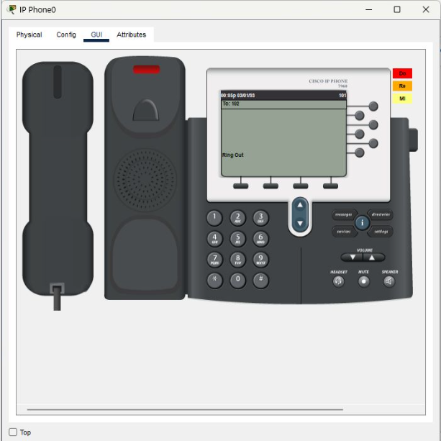

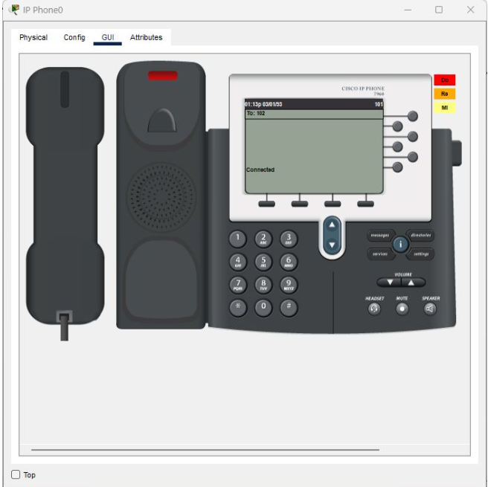

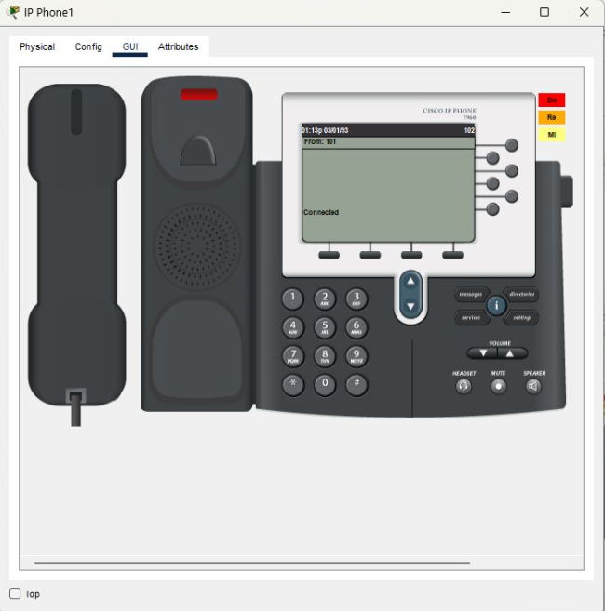

**Result of Scenario-3**

## **Scenario 4:**

**Result of Scenario-4**

## **Scenario 5:**

**Result of Scenario-5**

## 

## **Scenario 6:**

**Result of Scenario-6**

## **Scenario 7:**

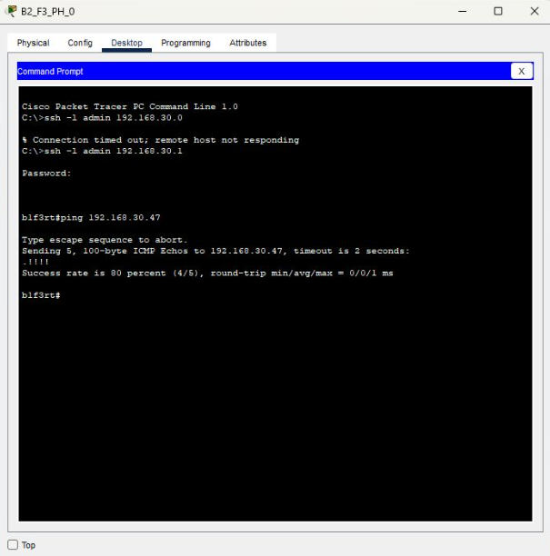

**Result of Scenario-7**

## **Scenario 8:**

Enter [www.turkiye.gov.tr](http://www.turkiye.gov.tr) from third facility of second branch by using smart phone.

**Result of Scenario-8**

## **Scenario 9:**

Ftp reques from branch1 facility1. Requested address: an ip address of a device that inside second branch second facility.

**Result of Scenario-9**

# **CHAPTER FOUR**

# **Conclusion**

This project involved designing a Metropolitan Area Network (MAN) using Cisco Packet Tracer software. The network included two branches, each with three facilities that had different user and device requirements.

The first branch's first facility had 3 workstation users, 3 wireless users, and 3 smartphone users. The second facility had 6 workstation users, with 2 used for VoIP conferencing. The third facility housed a server farm with 10 web servers, 4 FTP servers, 1 DHCP server, 1 mail server, and 1 DNS server.

The second branch's facilities included: the first with 5 workstation users, 5 wireless users and 5 tablet users; the second with 5 workstation users and 2 smartphone users; the third with 5 workstations and 2 mobile devices.

The design implemented at least two routers for each branch and connection technologies between the branches and Internet Service Provider to meet the network requirements and specifications.

This project successfully created a well-planned computer network architecture that supports a maximum number of users and traffic load with minimal delay. It also provides adequate hardware for network expansion while balancing costs against system needs.

# **CHAPTER FIVE**

# **References**

[1] Tanenbaum, A. S., & Wetherall, D. (2011). Computer Networks (5th ed.). Pearson.

[2] Cisco. (n.d.). Networking Terms Glossary. Retrieved from <https://www.cisco.com/c/en/us/support/docs/dial-access/asynchronous-connections/10029-glossary.html>

[3] Wehrle, K., Güneş, M., & Gross, J. (Eds.). (2010). Modeling and tools for network simulation. Springer Science & Business Media.

[4] Guizani, M., Rayes, A., Khan, B., & Al-Fuqaha, A. (2010). Network modeling and simulation: a practical perspective. John Wiley & Sons.

[5] NIST. (n.d.). Machine learning in network modeling and simulation. Retrieved from <https://www.nist.gov/programs-projects/machine-learning-network-modeling-and-simulation>

[6] W7cloud. (n.d.). Configuration of SSH on Cisco Switch in Packet Tracer. Retrieved from <https://w7cloud.com/configuration-of-ssh-on-cisco-switch/>

[7] YouTube. (n.d.). Configurar SSH en Router Cisco Packet Tracer. Retrieved from <https://www.youtube.com/watch?v=eVth4xXqnxg>

[8] Altuntaş, S. (n.d.). Cisco Router/Switch SSH konfigürasyonu. Retrieved from <https://salihaltuntas.com/cisco-router-switch-ssh-konfigurasyonu/>

[9] Cisco Systems. (n.d.). DHCP - Configuring the Cisco IOS DHCP Server [Support]. Retrieved from <https://www.cisco.com/en/US/docs/ios/12_4t/ip_addr/configuration/guide/htdhcpsv.html#wp1143732>

[10] Boyan, F. (n.d.). Cisco Router DHCP Yapılandırma. Retrieved from <https://www.firatboyan.com/cisco-router-uzerinde-dhcp-ayarlari-yapilandirma.aspx>

[11] YouTube. (n.d.). Simple PDU. Retrieved from <https://www.youtube.com/watch?v=NmMzIH0alV8&t>

[12] YouTube. (n.d.). DHCP DNS and Web Server configuration in cisco packet tracer. Retrieved from <https://www.youtube.com/watch?v=NmMzIH0alV8&t>

[13] YouTube. (n.d.). Packet Tracer Student: DHCP and DNS. Retrieved from <https://www.youtube.com/watch?v=7OxAKmFcvBk&t>

[14] YouTube. (n.d.). FTP Server Cisco Packet Tracer. Retrieved from <https://www.youtube.com/watch?v=MPTrbFzIn0Y>

[15] YouTube. (n.d.). Email Server Configuration in Cisco Packet Tracer | Cisco Packet Tracer Email Server || Mail Server. Retrieved from <https://www.youtube.com/watch?v=kVVZ1JAbOoI&t>

[16] YouTube. (n.d.). Subnet Mask Nedir ? Retrieved from <https://www.youtube.com/watch?v=FTWfCY-I7MY>

[17] YouTube. (n.d.). Subnet Mask - Explained. Retrieved from <https://www.youtube.com/watch?v=s_Ntt6eTn94>

[18] YouTube. (n.d.). 01 - IP Subnetting Nedir ? Network ve Broadcast Adresini Bulma. Retrieved from <https://www.youtube.com/watch?v=4s_odShdVYs&t>